Gayathri Sanjeev

David Madsen

IST 652

Final Project Report

Chicago Crime

Location and Weather Analysis

# Introduction

Crime in Chicago has been tracked by the Chicago Police Department’s Bureau of Records since the beginning of the 20th century. The city’s overall crime rate, especially the violent crime rate, is substantially higher than the US average. Chicago was responsible for nearly half of 2016’s increase in homicides in the US, though national crime rates stayed near historic lows. As of 2017, Chicago’s homicide rate is significantly higher when compared to the larger American cities of New York and Los Angeles, but lower when compared to smaller American cities. The reason for the violence, which is localized to some areas of the city, including change in police tactics or increase in gang rivalry remain unclear. (https://en.wikipedia.org/wiki/Crime\_in\_Chicago)

# Project Overview

Crime is a social phenomenon as old as societies themselves, and although there will never be a free society from crime - just because it would need everyone in that society to think and act in the same way - societies always look for a way to minimize it and prevent it. In the modern United States history, crime rates increased after World War II, peaking from the 1970s to the early 1990s. Violent crime nearly quadrupled between 1960 and its peak in 1991. Property crime more than doubled over the same period. Since the 1990s, however, crime in the United States has declined steadily. (https://en.wikipedia.org/wiki/Crime\_in\_the\_United\_States) Until recently, crime prevention was studied based on strict behavioral and social methods, but the recent developments in Data Analysis have allowed a more quantitative approach in the subject. We will explore a dataset of nearly 17 years of crime reports from across all of Chicago’s neighborhoods, and we will create a model that predicts the primary category of crime that occurred, given the location description code and beat.

# Data & Data Source

This dataset reflects reported incidents of crime (except for murders where data exists for each victim) that occurred in the City of Chicago from 2001 to 2017. Data is extracted from the Chicago Police Department's CLEAR (Citizen Law Enforcement Analysis and Reporting) system. In order to protect the privacy of crime victims, addresses are shown at the block level only and specific locations are not identified. Disclaimer: These crimes may be based upon preliminary information supplied to the Police Department by the reporting parties that have not been verified. The preliminary crime classifications may be changed later based upon additional investigation and there is always the possibility of mechanical or human error. Therefore, the Chicago Police Department does not guarantee (either expressed or implied) the accuracy, completeness, timeliness, or correct sequencing of the information and the information should not be used for comparison purposes over time. The dataset was pulled from the website ([https://data.cityofchicago.org/Public-Safety/Crimes-2001-to-present/ijzp-q8t2](https://data.cityofchicago.org/Public-Safety/Crimes-2001-to-present/ijzp-q8t2" \t "_blank))

## Chicago Crime Dataset Attributes

|  |  |
| --- | --- |
| Id | Unique identifier for the record. |
| Case Number | The Chicago Police Department RD Number (Records Division Number), which is unique to the incident. |
| Date |  |
| Block | The partially redacted address where the incident occurred, placing it on the same block as the actual address. |
| IUCR | The Illinois Uniform Crime Reporting code. This is directly linked to the Primary Type and Description. See the list of IUCR codes at <https://data.cityofchicago.org/d/c7ck-438e>. |
| Primary Type | The primary description of the IUCR code. |
| Description | The secondary description of the IUCR code, a subcategory of the primary description. |
| Location Description | Description of the location where the incident occurred. |
| Arrest | Indicates whether an arrest was made. |
| Domestic | Indicates whether the incident was domestic-related as defined by the Illinois Domestic Violence Act. |
| Beat |  |
| District |  |
| Ward |  |
| Community Area |  |
| FBI Code |  |
| X Coordinate |  |
| Y Coordinate |  |
| Year | Year the incident occurred. |
| Updated On | Date and time the record was last updated. |
| Latitude |  |
| Longitude |  |
| Location | The location where the incident occurred in a format that allows for creation of maps and other geographic operations on this data portal. This location is shifted from the actual location for partial redaction but falls on the same block. |

## Weather Data

Two different datasets were collected for weather data. The difference between the two is the different areas in the city they were collected from. The first weather dataset was collected from the City of Chicago website (<https://data.cityofchicago.org/Parks-Recreation/Beach-Weather-Stations-Automated-Sensors/k7hf-8y75>). The Chicago Park District maintains weather sensors at beaches along Chicago's Lake Michigan lakefront. These sensors generally capture the indicated measurements hourly while the sensors are in operation during the summer. During other seasons and at some other times, information from the sensors may not be available.

### Chicago Parks & Recreation Beach Weather Dataset Attributes

|  |  |
| --- | --- |
| Station Name |  |
| Measurement Timestamp | The date and time when the measurements were taken. |
| Air Temperature | Air Temperature in Celsius degrees. |
| Wet Bulb Temperature | Wet bulb temperature in Celsius degrees. |
| Humidity | Percent relative humidity. |
| Rain Intensity | Rain intensity in mm per hour. |
| Interval Rain | Rain since the last hourly measurement, in mm. |
| Total Rain | Total rain since midnight in mm. |
| Precipitation Type |  |
| Wind Direction | Wind direction in degrees. |
| Wind Speed | Wind speed in meters per second. |
| Maximum Wind Speed | Maximum wind speed since midnight in meters per second. |
| Barometric Pressure | Barometric pressure in hPa. |
| Solar Radiation | Solar radiation in watts per square meter. |
| Heading | . |
| Battery Life | Battery voltage, an indicator of remaining battery life used by the Chicago Park District to know when batteries should be replaced. |
| Measurement Timestamp Label | The Last Updated value in text format, suitable for use in the Visualize function. |
| Measurement ID | A unique record ID made up of the Station Name and Measurement Timestamp. |

The second weather dataset (<https://www.kaggle.com/yochanan/chicago-weather>), contributed to kaggle.com from measurements taken between 2008 and 2015 at Chicago Midway Airport by NOAA (<https://www.ncdc.noaa.gov/>). This was data which was specifically curated by a Kaggle.com user for use with the Chicago crimes data (a subset of the data mentioned above) also available from the same site. It is offered under the Creative Commons license.

There was no data dictionary provided with this data set therefore only attribute names are presented.

### Midway Airport Weather Dataset Attributes

|  |
| --- |
| STATION |
| STATION NAME |
| ELEVATION |
| LATITUDE |
| LONGITUDE |
| DATE |
| REPORT TYPE |
| HOURLYSKYCONDITIONS |
| HOURLYVISIBILITY |
| HOURLYPRSENTWEATHERTYPE |
| HOURLYDRYBULBTEMPF |
| HOURLYDRYBUBLTEMPC |
| HOURLYWETBULBTEMPF |
| HOURLYWETBULBTEMPC |
| HOURLYDewPointTempF |
| HOURLYDewPointTempC |
| HOURLYRelativeHumidity |
| HOURLYWindSpeed |
| HOURLYWindDirection |
| HOURLYWindGustSpeed |
| HOURLYStationPressure |
| HOURLYPressureChange |
| HOURLYSeaLevelPressure |
| HOURLYPrecip |
| HOURLYAltimeterSetting |
| DAILYMaximumDryBulbTemp |
| DAILYMinimumDryBulbTemp |
| DAILYAverageDryBulbTemp |
| DAILYDeptFromNormalAverageTemp |
| DAILYAverageRelativeHumidity |
| DAILYAverageDewPointTemp |
| DAILYAverageWetBulbTemp |
| DAILYHeatingDegreeDays |
| DAILYCoolingDegreeDays |
| DAILYSunrise |
| DAILYSunset |
| DAILYWeather |
| DAILYPrecip |
| DAILYSnowfall |
| DAILYSnowDepth |
| DAILYAverageStationPressure |
| DAILYAverageSeaLevelPressure |
| DAILYAverageWindSpeed |
| DAILYPeakWindSpeed |
| PeakWindDirection |
| DAILYSustainedWindSpeed |
| DAILYSustainedWindDirection |
| MontlyMaximumTemp |
| MonthlyMinimumTemp |
| MonthlyMeanTemp |
| MonthlyAverageRH |
| MonthlyDewpointTemp |
| MonthlyWetBulbTemp |
| MonthlyAvgHeatingDegreeDays |
| MonthlyAvgCoolingDegreeDays |
| MonthlyStationPressure |
| MonthlySeaLevelPressure |
| MonthlyAverageWindSpeed |
| MonthlyTotalSnowfall |
| MonthlyDeptFromNormalMaximumTemp |
| MonthlyDeptFromNormalMinimumTemp |
| MonthlyDeptFromNormalPrecip |
| MonthlyTotalLiquidPrecip |
| MonthlyGreatestPrecip |
| MonthlyGreatestSnowfall |
| MonthlyGreatestSnowfallDate |
| MonthlyGreatestSnowfallDepth |
| MonthlyGreatestSnowDepthDate |
| MonthlyDaysWithGT90Temp |
| MonthlyDaysWithLT32Temp |
| MonthlyDaysWithGT32Temp |
| MonthlyDaysWithLT0Temp |
| MonthlyDaysWithGT001Precip |
| MonthlyDaysWithGT010Precip |
| MonthlyDaysWithGT1Snow |
| MonthlyMaxSeaLevelPressureValue |
| MonthlyMaxSeaLevelPressureDate |
| MonthlyMaxSeaLevelPressureTime |
| MonthlyMinSeaLevelPressureValue |
| MonthlyMinSeaLevelPressureDate |
| MonthlyMinSeaLevelPressureTime |
| MonthlyTotalHeatingDegreeDays |
| MonthlyTotalCoolingDegreeDays |
| MonthlyDeptFromNormalHeatingDD |
| MonthlyDeptFromNormalCoolingDD |
| MonthlyTotalSeasonToDateHeatingDD |
| MonthlyTotalSeasonToDateCoolingDD |

# Problem Statement

To examine the specific problem, we will apply a full Data Science life cycle composed of the following steps:

1. Data cleaning to audit the quality of the data and perform all the necessary actions to clean the dataset.
2. Data Exploration for understanding the variables and create intuition on the data.
3. Feature Engineering to pull important variables from the existing.
4. Data Normalization and Data Transformation for preparing the dataset for the learning algorithms (if needed).
5. Apply correlation and regression methods to find if there is a correlation between crime and weather.
6. Split data into train / test data to evaluate the performance of our models and fine-tune their hyperparameters.
7. Model selection and evaluation. This will be the final goal; creating a model that predicts the Primary type of crime based on the location description and the beat.

# Data Preprocessing

As mentioned earlier in the report, two different weather datasets were used to analyze the relation between crime and weather.

## First Dataset (2015 – 2017) (Beach station weather dataset)

Since we don’t need all the columns out of these datasets, only those columns that are required for our analysis were pulled out during the import of these datasets. From the Crime dataset, columns Date, Block, IUCR, Primary Type, Beat, District, Ward, Community Area, FBI Code, Latitude, Longitude, Location, Zip Codes were pulled out. From the Weather Dataset, we are only interested in three columns for now. Columns Measurement Timestamp, Air Temperature and Total Rain were pulled out. The dataset columns were renamed for easy use, date was converted to datetime datatype. NA values were dropped from the weather dataset.

Keeping in mind the vast amount of data, we filtered the dates from both datasets to reflect only data between the years 2015 to 2017 since the weather dataset collected from beach stations only has information between these years. Once the datasets were filtered by date, both datasets were merged for further analysis. This merged dataset is called CW\_merged.csv. This merged dataset was only used to find the correlation between weather and crime. For all other exploratory data analysis and prediction models, the crime dataset was used on its own so that data from all the years (2001-2019) can be used.

## Second Dataset (2008 – 2015) (Midway Airport weather dataset)

A different timespan was used for the second analysis, and a slightly smaller subset of columns was used. For instance, the only location data which was preserved was Ward. Ward can be a tricky data column as it is numeric and by default will be treated as such however the data isn’t necessarily ordered and the numeric data is better treated as nominative. For this reason, Ward was one hot encoded into forty-nine separate binary columns representing wards two through fifty. The first ward was omitted as a column and represented in the data as a value of zero for all other wards.

The Midway airport weather data was used for this analysis. This dataset proved useful but was overall disappointing. Many columns lacked data and were possibly artifacts of a previous feature extraction which was not realized in the final document. There were several distinct ‘report types’ compiled in this data, but for the purpose of this analysis, only the report type which featured aggregate daily reports was consumed. Columns for which this report type provided no data were dropped leaving only daily measurements of temperature and precipitation as relevant data. Location data was likewise dropped as all measurements came from the same Midway Airport weather station making the data irrelevant in analysis.

For each dataset, the date column for the event or measurement taken was converted to a pandas datetime object and was then normalized so all dates were in the form of Year-Month-Day 12:00 AM. This date was then used as the join key to merge the two datasets. As the crime data spanned a greater range than the weather, an inner type join was used to limit the analysis to date ranges where both crime and weather data were available.

Now that the data is clean and is in the required format, we can do some exploratory data analysis on the dataset to see what the data can tell you. Let's plot some graphs to see how the crime rates in Chicago differ over the years (2001-2019) and over the months and days in a month.

# Analysis

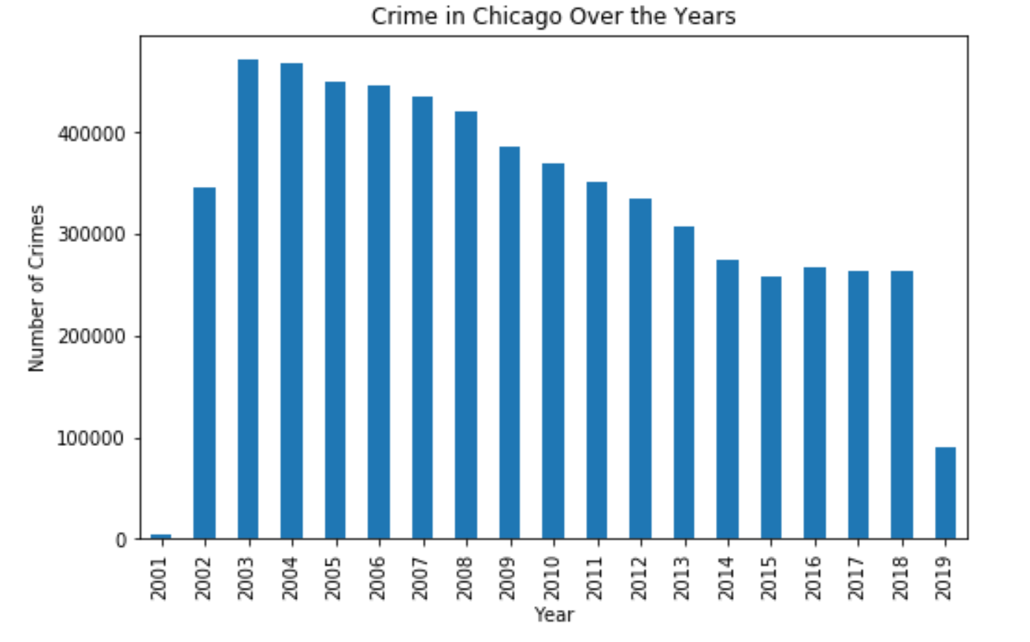

The above chart shows that crime rates have been going down over the years as opposed to the contrary belief that crime rates are rising. Growth of technology and media, making news of these events more readily available and to a broader audience may have helped fuel this misconception, but the truth lies in the data that can be seen above.

Looking at the total number of crimes which have occurred in any given month (below bar graph) suggests a seasonality to crime rates. Crime rates peak towards the middle of the year during June and July and fade towards the latter part of the year just like it was at the beginning months of a year. Another interesting point to note here is that the month of February is the month with the least number of crimes.

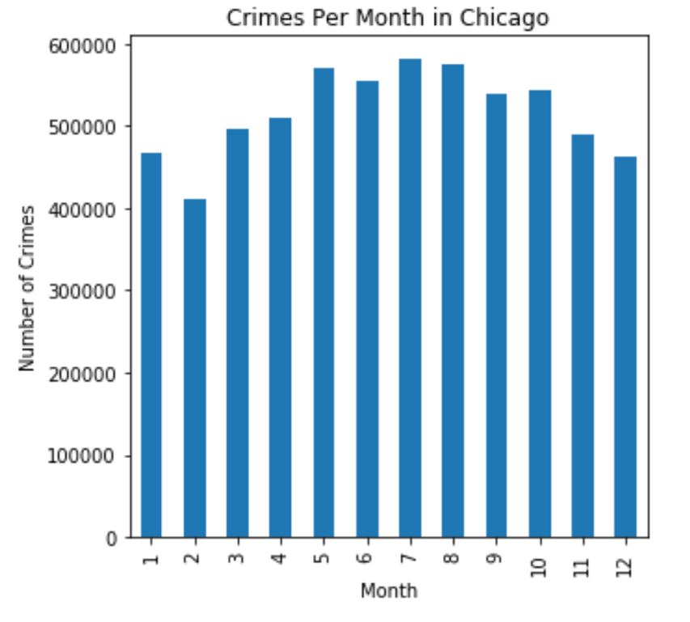

Indeed, looking at the average number of crimes per month by each of the top ‘primary types’ using the graphs below illustrates this same seasonality. Although the overall peaks differ from type to type, the lowest tends to remain in February.

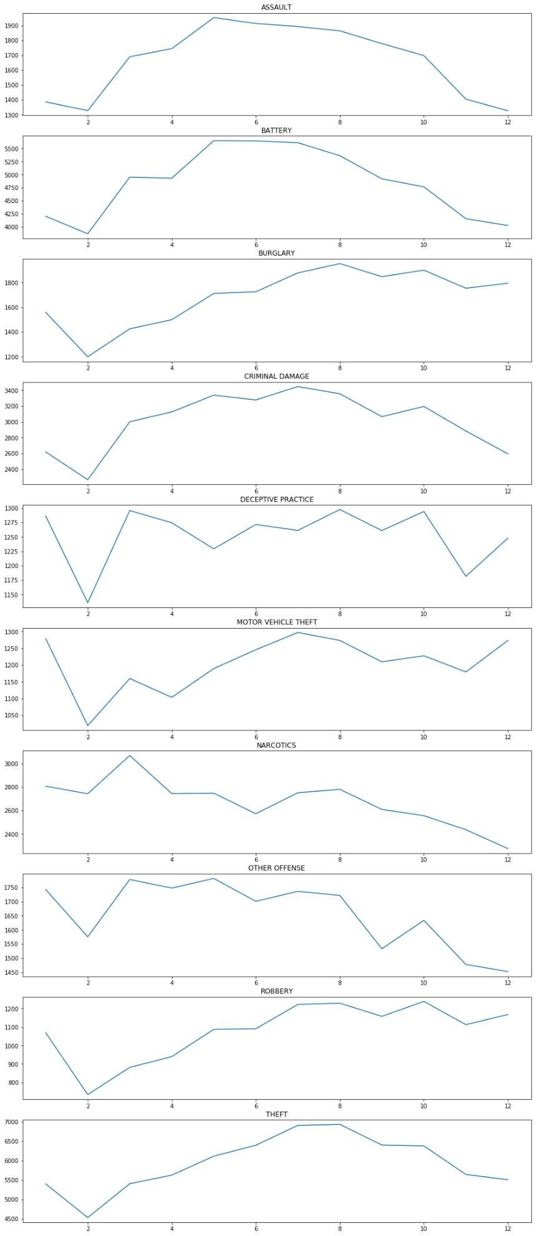

The below chart shows the crime rate per day. It shows that the numbers are almost the same at every day of a month except for the first and last day of the month. The first day of the month has a dramatic surge in the number of crimes. It would be interesting to analyze what type of crime is being committed on the first day. It's most probably thefts but it would be interesting to see what kind of trend other type of crimes follow. Also, the last day of the month is the day when there are least number of crimes however one should note a slight uptick in crimes on the 28th day of the month. The drop in the crime rate observed on the 29th and further drop on the 30th is likely due to the 29th of February occurring only once every four years and thus having less representation in the dataset overall, and the 30th never having representation in February. Likewise, much of the dramatic drop in total crimes on the 31st of the month can be explained by the simple fact that only seven months have 31 days.

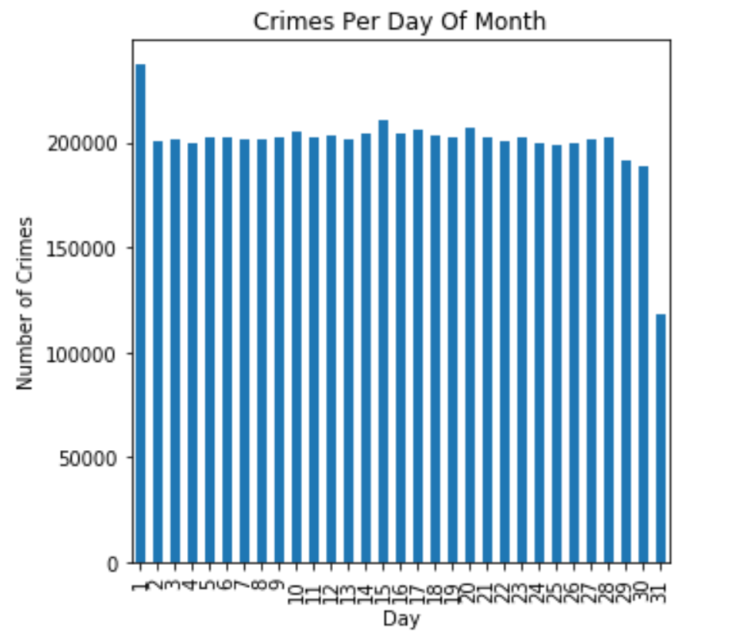

Another graph shows the crimes committed per hour. We can see from the below plot that the greatest number of crimes are committed at noon and between noon and 10 pm whereas the least number of crimes are committed between 1 am to 7 am. Again, it would be interesting to see the variation between different types of crimes.

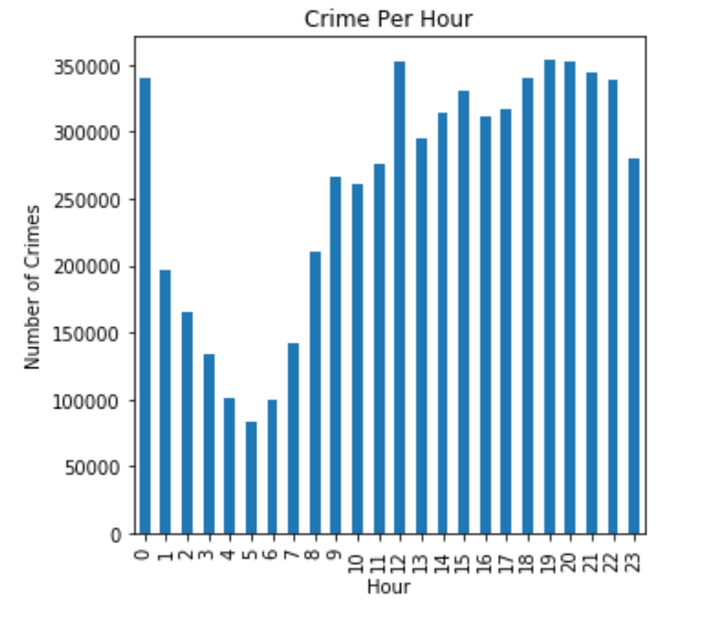

Next, let's see what type of locations have the greatest number of crimes.

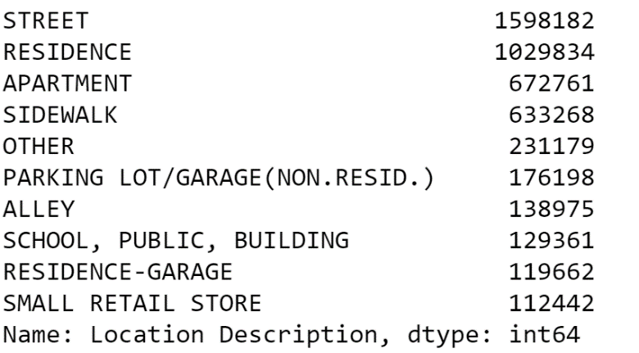

The above result shows the top 10 location descriptions where the greatest number of crimes were committed. It seems street crimes top the list followed by residential, apartment and sidewalk crimes.

Next, let's see what type of descriptions had the greatest number of crimes?

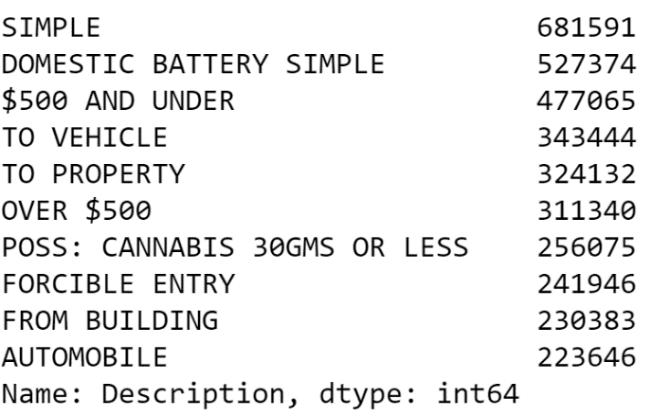

The above results show that the greatest number of crimes committed were simple and for money that involved $500 or under.

Next, let's see what was the primary type of crime that was committed the most?

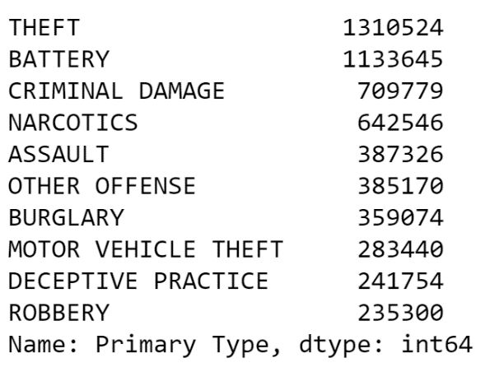

The following chart taken from the 2008 – 2015 curated data illustrates the propensity for theft and battery to be committed over other crimes.

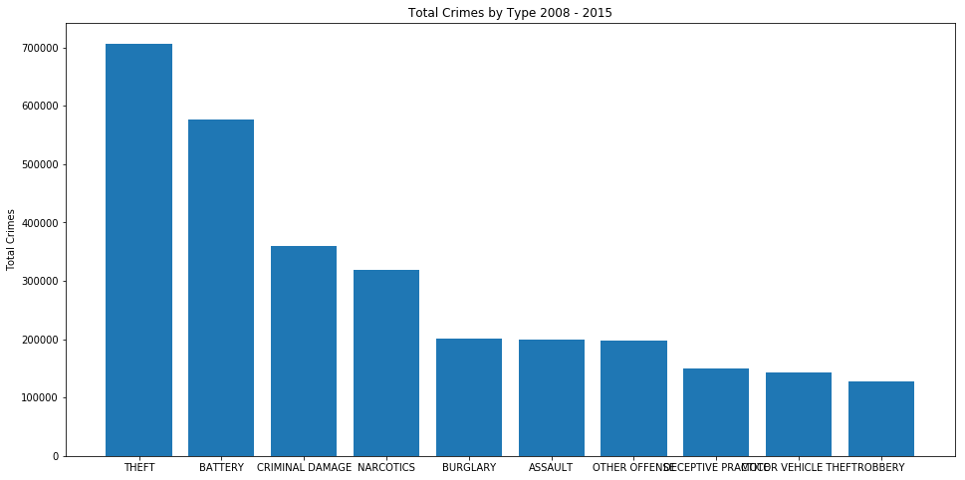

The above results show that theft was the number one crime.

The next step would be to be able to see these results interactively on a map of Chicago to see those areas or locations with the highest crime rates. Using folium package, we can get a map and chart these crime locations on the map. With this, we can answer a couple of comparison questions using the Chicago map. The first question is to find out the most common type of crimes being committed by location. To do this, another new data frame is created by grouping the data by Primary Type column. This new data frame, PrimaryCrime\_locations, has the latitude, longitude, location description, arrest and the Primary Type columns.

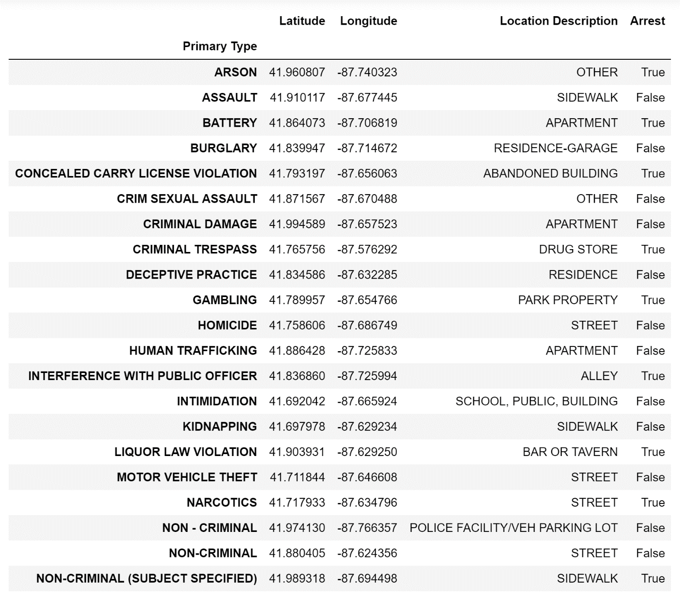

Next, this new dataframe is fed into the graph and values are set.

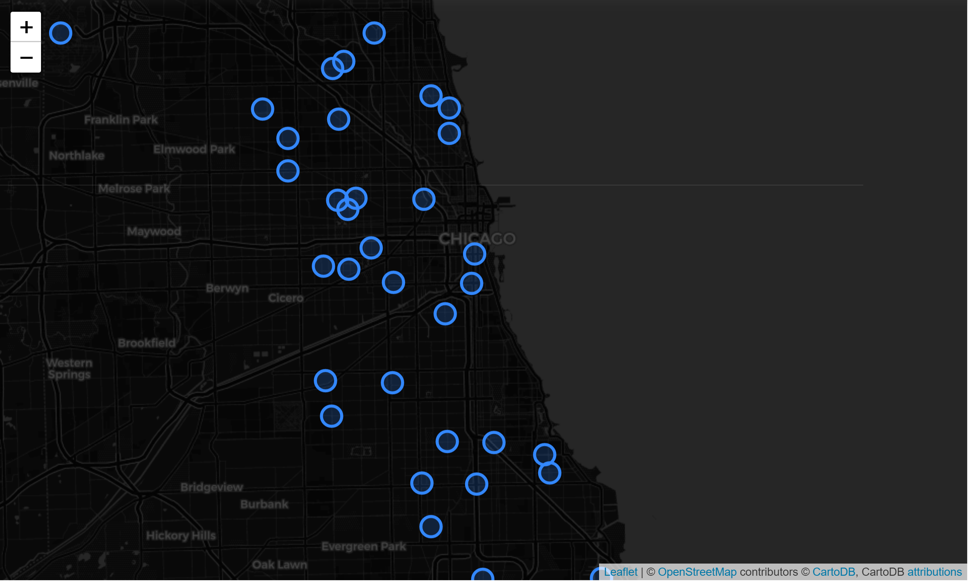

The above map shows an image of the most common primary crime type by location. When one clicks on a blue circle on the original map, one can see the location description, latitude, longitude and whether an arrest was made or not for that primary crime type. For example, if you zoom in on the blue circle in the 'loop' area, the city’s commercial core, the most common primary crime type is non-criminal and most of this type happens in the streets of the loop.

For the next question, the unit of analysis here is the total number of crimes committed by location. Mind that there is a lot of repetition of the locations in the data frame. Hence, first, we will filter the values by unique locations and then use that data to plot on the map. Let's compare how many locations have more than 3000 crimes committed over the years.

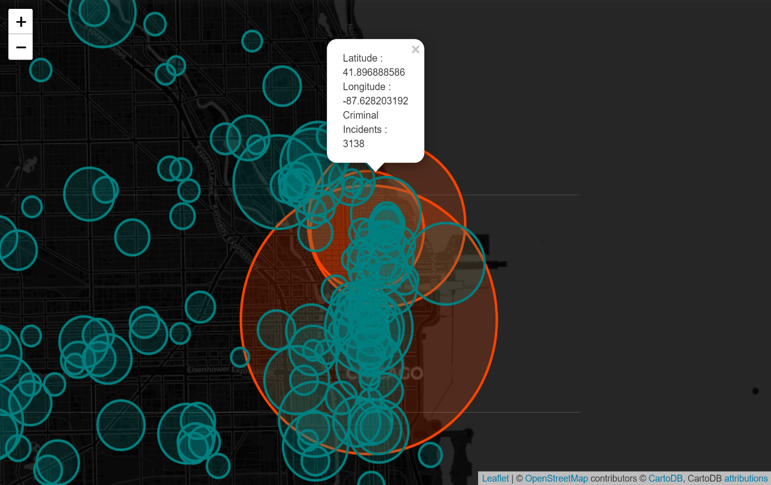

We can see from the above map that there are approximately 4 locations with criminal incidents more than 3000 over the past 18 years. If you hover over one of the orange circles and click on it, it will show you the number of crimes committed.

By zooming into one of the orange circles, we can see that the Chicago loop area has a high number, 3138, criminal incidents over the years of 2001 to 2019.This is quite baffling and at the same time obvious considering these two places are highly populated and high traffic areas. Again, it would be interesting to draw more maps by separating them by primary crime type to see if these areas change. We suspect for now that the thefts are the most common type of crime in these areas.

After considering various algorithm models to predict the primary type of crime, we zeroed in on the XGBoost algorithm because of its speed and performance. Just to give a brief overview of this algorithm, it uses boosting technique to combine a set of weak learners and delivers improved prediction accuracy. The outcomes that were misclassified are given a higher weight than the ones that were correctly classified. the basic idea behind boosting algorithms is building a weak model, making conclusions about the various feature importance and parameters, and then using those conclusions to build a new, stronger model and capitalize on the misclassification error of the previous model and try to reduce it. One way to visualize this model is to visualize the decision trees from the fully boosted model that the algorithm creates using the entire crime dataset. We can see that the model arrived at its final decisions using the Location Description code as the main attribute to make the splits. (https://www.datacamp.com/community/tutorials/xgboost-in-python)

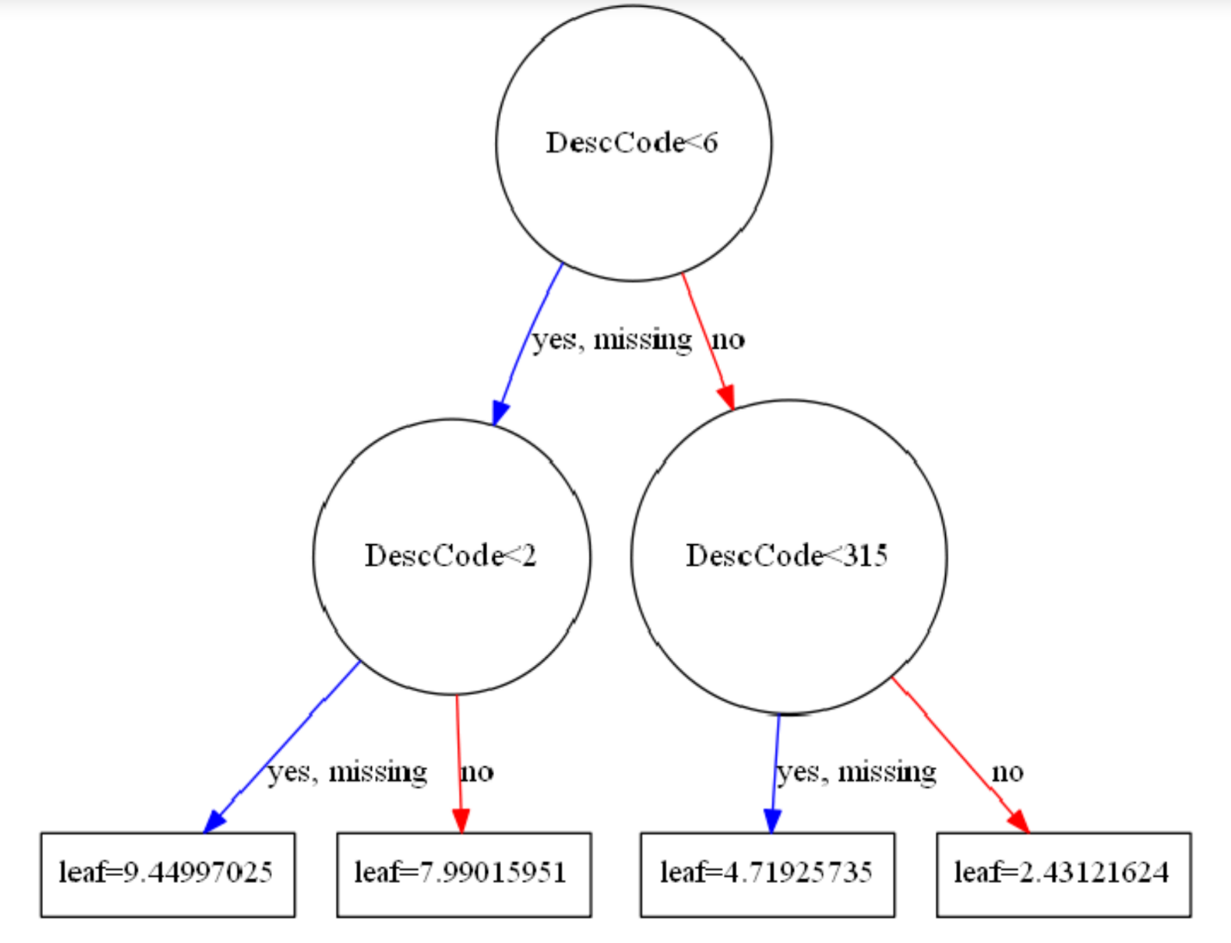

Root Mean Square Error (RMSE) performance metric was used to check the performance of the trained model on the test set. Root mean Squared error is the square root of the mean of the squared differences between the actual and the predicted values. With the initial parameters set and without doing any cross-validation, the RMSE of this algorithm without cross-validation was 9.94.

To build a more robust model, 3-fold cross validation was used where all the entries in the original training dataset are used both for training as well as validation. Along with this, the important features from the above visualization was used for the newer model. This helped to reduce the root mean square error. The RMSE for the primary type crime prediction reduced as compared to last time and came out to be around 5.48. Note that an even lower RMSE can be obtained by tuning the hyper-parameters.

Another way to visualize the model is to examine the importance of each feature column in the original dataset within the model. The way the model does this is by counting the number of times each feature is split on across all boosting rounds(trees) in the model and then visualizing the result using a bar graph. We can see that some of the important features that the model used were latitude, location desc code, beat and longitude. Using these important features, the model was generated again to predict and the RMSE improved to 5.19 with cross-validation.

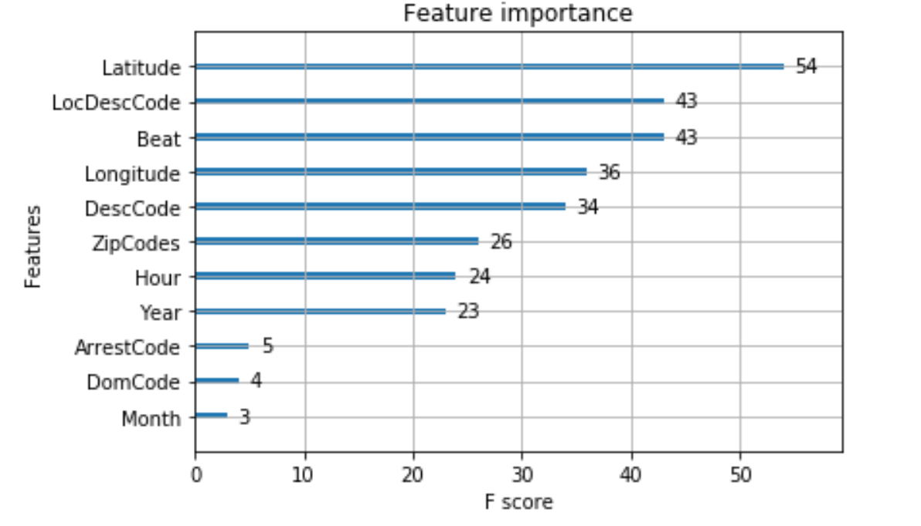

Moving on to the analysis about crime and weather (beach station) analysis dataset, strong correlations could be found between the temperature and crime committed on a specific day. But there is not much of a strong correlation between precipitation and crime on a specific day. The below scatter plots depict the same.

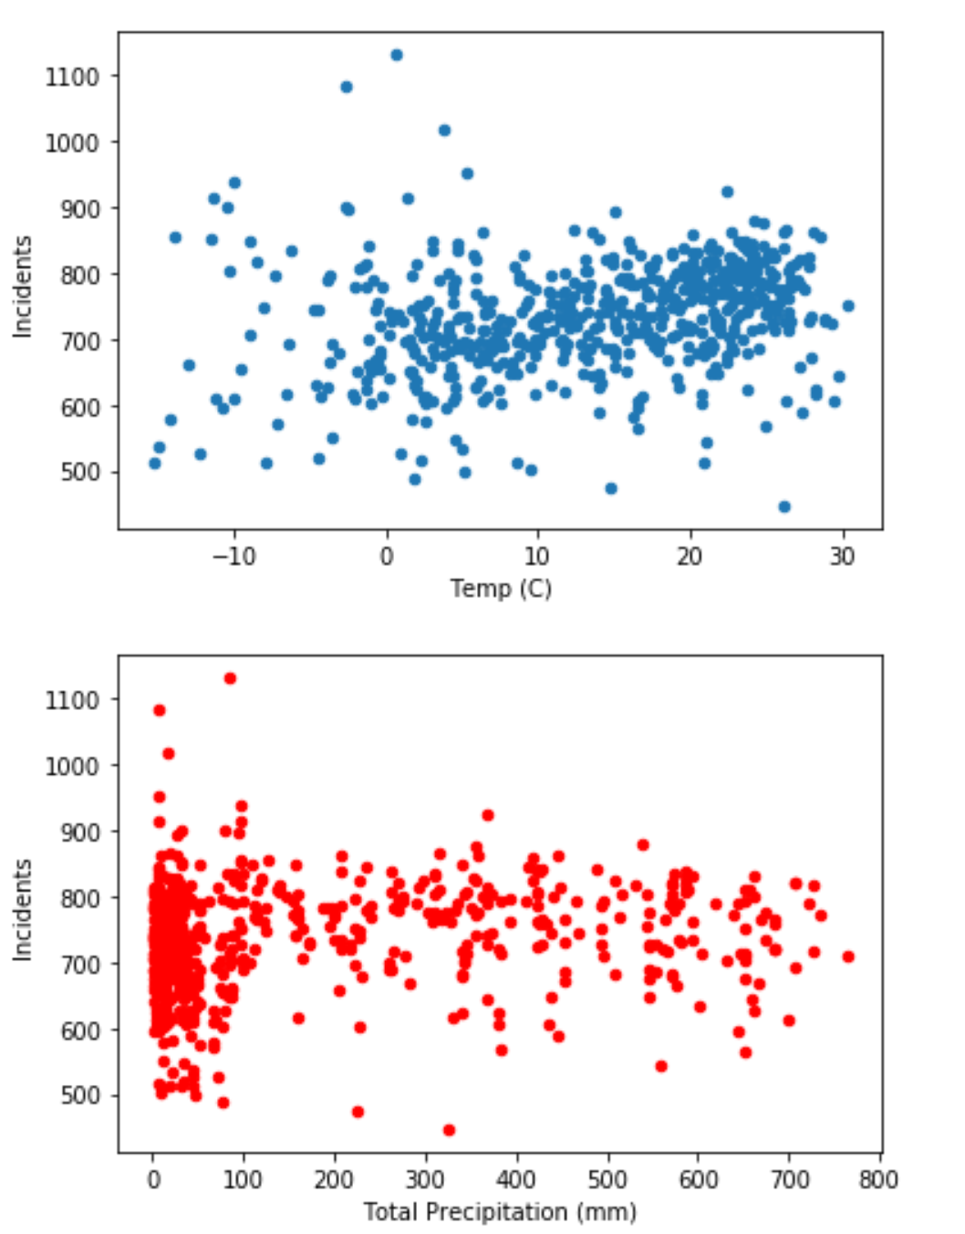



Using the second weather dataset from the Midway Airport, several complex models were attempted to learn more about how weather affects crime in the city. Naïve Bayes and Support Vector Machine base models were attempted, but their predictability was not much better than the trivial “majority vote” case. After some reconsideration, a regression analysis was used.

Multivariate linear regression was chosen with the unit of analysis chosen as the total number of crimes committed in a given day. The variables considered were exclusively from the Midway weather data set and included maximum, minimum and average temperatures as well as sunrise, sunset and precipitation. The results were not very promising but did yield some minor insights.

Thus, there is so much more to explore with this dataset. We could ask many more questions and combine various other data sources to come up with newer findings. We could probably combine weather datasets with this data to see if weather had an impact on the type of crime that was committed on a day or season.

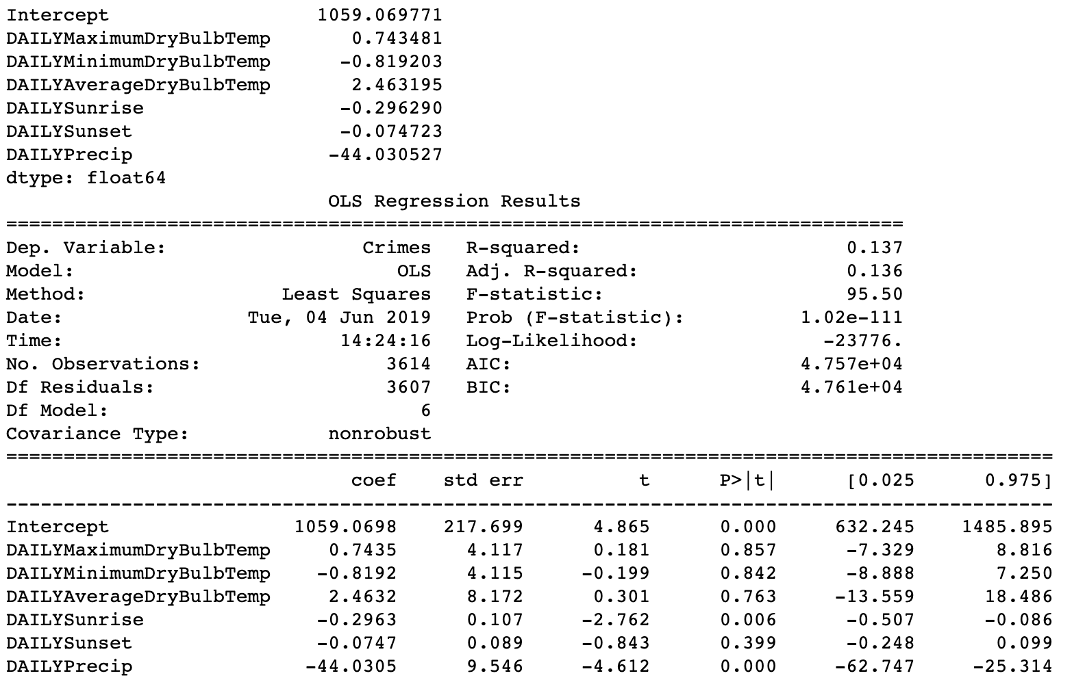

The P-values for daily sunrise and precipitation suggest they have a significant effect on how many crimes are committed on a given day in Chicago.

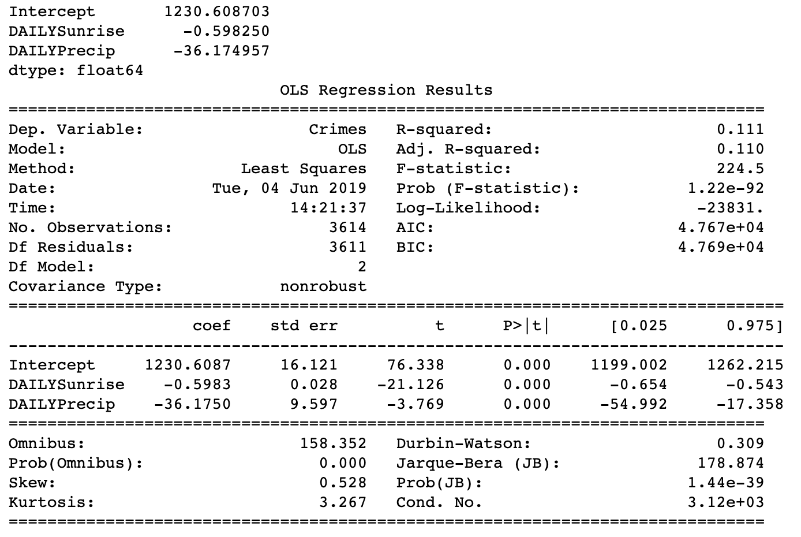

Limiting the analysis to only sunrise and precipitation reinforces that result however only accounts for about 11% of the variability in the number of crimes.

It turns out that while weather, at least the time of sunrise (seasonality) and precipitation, plays a role in the number of crimes we see in Chicago, the greater role is played by location as already suggested. Bringing a ward by ward breakdown into the data shows each ward contributes in a statistically significant way to the number of crimes on a given day.

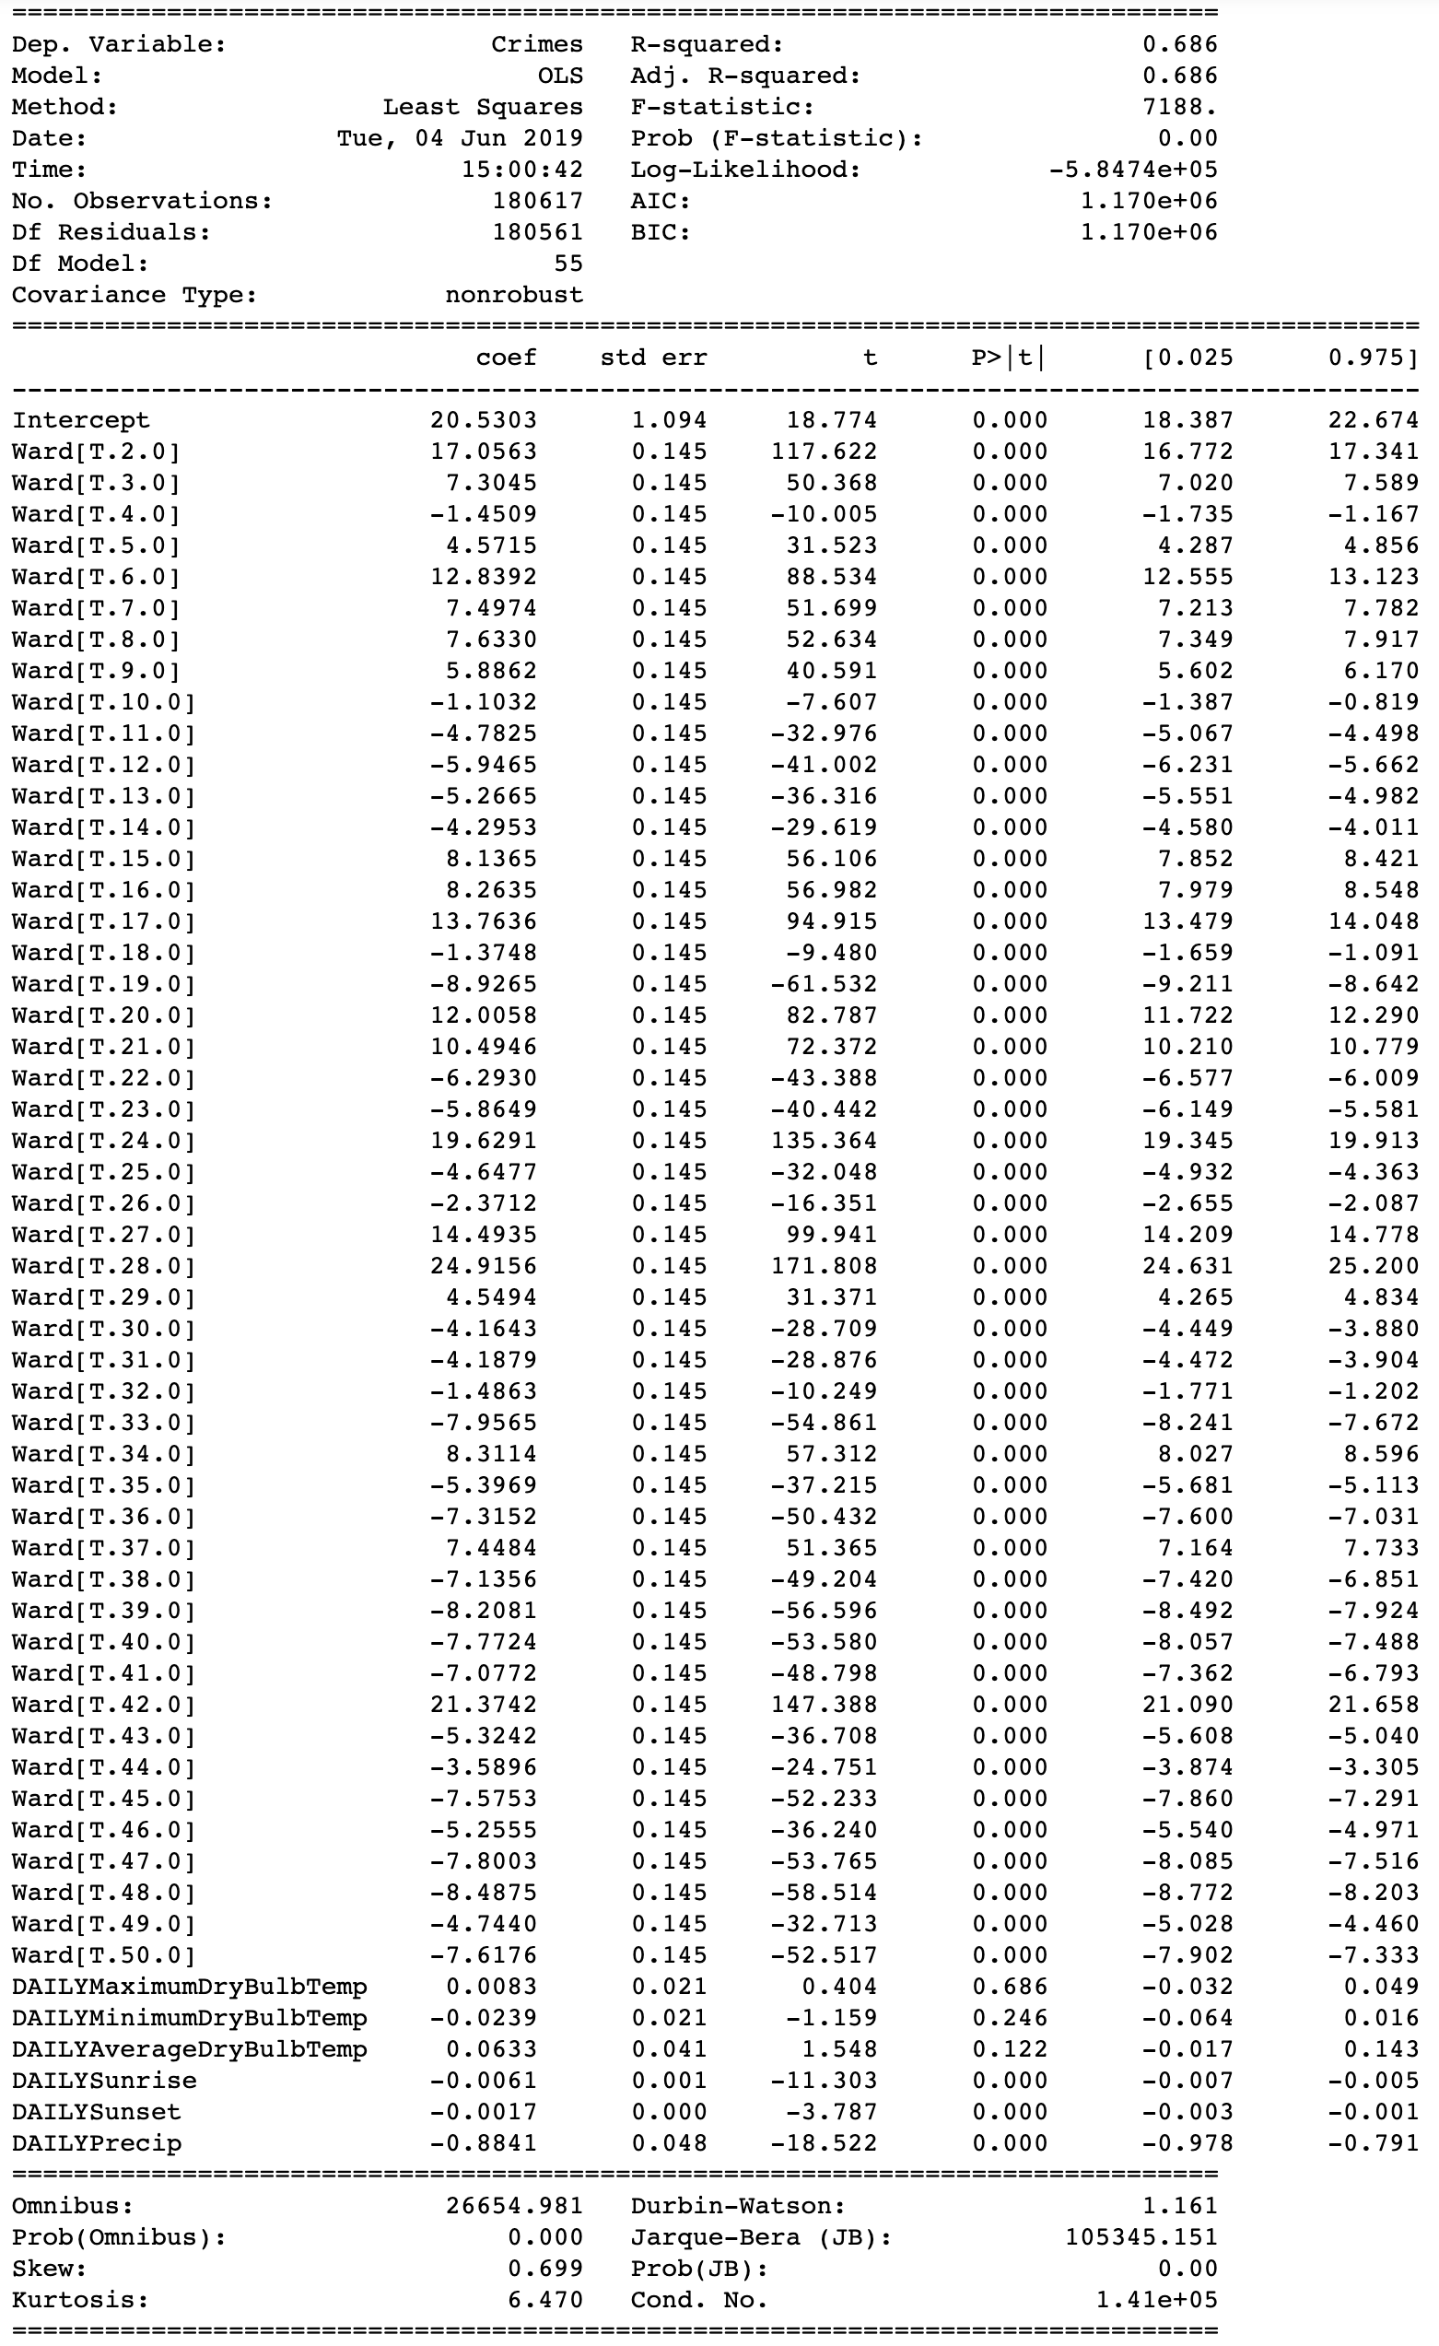

The interpretation of these results begins with the 1st ward where we expect 20-21 crimes on any given days with a slight correction based on sunrise, sunset and precipitation. As our variable for the ward variables only takes on values of 1 or 0, we can interpret the coefficient for each ward as the ± for that ward over or under the 1st ward. For example, on a day where there are 20 crimes in the first ward, we expect to see about 41 in the 42nd ward. Of course, it needs to be noted this is no way exact, but a statistical representation which according to the R2 value only represents just under 70% of the variability in the crimes committed.

# Overall description of the Programs

The first program (Sanjeev\_Madsen\_Crime&Weather) first imports all the necessary libraries and reads in both the Chicago crime dataset and the Chicago weather dataset collected from beach stations and only uses specific columns from the dataset to import. For weather, it only imports measurement timestamp, air temperature and total rain columns. These columns are renamed for readability and easy understanding and the date column is converted to the right datatype which is datetime. The same is applied to the crime dataset as well. The crime dataset is also sorted by dates and all the na values are dropped in both the crime and weather datasets. These two datasets are merged by using the date column and filtering those values between 2015 and 2017. Later, these two datasets are merged by the column Date and written into a CSV file. Some of the extra columns that got created during this merge are dropped off while importing this new merged csv file so that they can be used for analysis later if needed.

For now, the program merges the crime and weather dataset using a data frame and uses scatter plots with precipitation and temperature on the X axis and number of incidents on the Y axis.

Finally, the program uses linear regression function to find a relation between temperature and number of incidents and precipitation and number of incidents. The program once again uses the plot function to get the scatter plots.

The second program (Sanjeev\_Madsen\_ProjectFinal) first imports all the necessary libraries and reads in the Chicago crime dataset (Crimes\_-\_2001\_to\_present.csv) by parsing through the Date column. It drops all the unnecessary and duplicate columns that are not required for the analysis like Case Number, historical Wards, Police Districts, Police Beats, X Coordinate, Y Coordinate etc. Later, it checks for any null values and drops all the nan values off the dataset since it’s meaningless to have any rows that are missing any one of the column values. Replacing it with mean or median values don’t make sense in this dataset.

The program also checks the datatypes of the columns to see if they have the right datatype format and converts some of the columns into integer datatypes. The date column is also converted into the datetime type and made as the index column. The program extracts two new columns from the date column – hour and month. Now that the data is clean and preprocessed, the program moves on to do some exploratory analysis by using pyplot module from the matplotlib package.

Crimes in Chicago over the years, over months, days and hours are some of the plots created using matplotlib. Pyplot is also used to count the number of crimes committed by Location Description and the same is plotted using a bar graph. Using pandas’ package, the program also shows the counts of crimes by primary type and description.

Using the folium package, a couple of maps were generated to visualize the number of crimes and most common primary type of crime by neighborhood on the Chicago city map. The map intakes the latitude and longitude columns, groups the data by primary type and uses the Arrest, location description, latitude and longitude columns for the popups and outputs the map. CR\_index is the new data frame which has only the unique locations and the number of crimes aggregated over those locations. Since the location has both latitude and longitude in the same column, a user-built location\_extractor function is used to separate the values into latitude and longitude and returned to the CR\_index data frame column as 'LocationCoord'. Since the raw-string column is not required anymore, it is dropped. Next, we use the folium package once again and a 'for' loop to go through the values in the CR\_index data frame and chart them on the map. If the Value Count of a location is more than 3000, then an orange circle will be drawn on the map. If not, a green color circle will be drawn.

Next, the program uses the label encoder module form sklearn package to convert or encode the categorical columns into numerical columns so that prediction algorithms can be applied on the same. Primary type, Description, Location Description, Arrest, Domestic are the columns that were encoded. Also, some of the columns were renamed to avoid spaces in between the column names since this was causing an issue while running the prediction algorithms.

Correlation function was used to see if any of the columns have correlation with each other so that we can avoid skewing of the results. The correlation function showed that the columns Beat, District, Ward have a strong correlation and it’s wise to use just one of the columns for our prediction models to avoid skewing. Hence, before using the prediction algorithm, the dataset was split into two data frames. The X data frame consisted of the columns Beat, Community Area, Year, Latitude, Longitude, Zip Codes, Description Code, Location Description Code, Domestic Code, Arrest Code, Hour and Month. The Y data frame just consists of the variable that is going to be predicted which is the Primary Type Code. Once this is done, the datasets were split into training and test dataset using the 70-30 split.

Now that we have the training and test datasets ready, the dataset was converted into an optimized data structure called dmatrix that XGBoost supports and gives it acclaimed performance and efficiency gains.

The next step is to instantiate an XGBoost regressor object by calling the XGBRegressor () class from the XGBoost library with the hyper-parameters passed as arguments. Fit the regressor to the training set and make predictions on the test set using the familiar .fit() and .predict() methods. The program checks for root mean square error (RMSE) which comes up to 9.94 to test the accuracy of the model.

To build a more robust model, a 3-fold cross validation was used where all the entries in the original training dataset are used for both training as well as validation. The program specifies the nfolds parameter which is the number of cross validation sets you want to build. A hyper-parameter dictionary params which holds all the hyper-parameters and their values as key-value pairs is also used. The program uses these parameters to build a 3-fold cross validation model by invoking XGBoost's cv () method and store the results in a cv\_results Data Frame. cv\_results show the train and test RMSE metrics for each boosting round. By extracting the final boosting round metric, the program shows that the RMSE for the primary type prediction has reduced as compared to last time and came out to be around 5.48 which shows that this is a better model than the previous one.

The last part of this program shows how one can visualize the XGBoost algorithm by visualizing the individual trees from the fully boosted model that XGBoost creates using the entire crime dataset. The trained model is passed to the plot\_tree () function along with the number of trees you want to plot using the num\_trees argument. Finally, using the matplotlib library, the tree is plotted. These plots provide insight into how the model arrived at its final decisions and what splits it made to arrive at those decisions.

Another way to visualize the model is to examine the importance of each feature column in the original dataset within the model. The program uses the plot\_importance () function counts the number of times each feature is split on across all boosting rounds (trees) in the model, and then visualizes the result as a bar graph, with the features ordered according to how many times they appear. Using the most important features from this graph, the program builds another model with 3-fold cross validation for which the RMSE goes further down to 5.19.

The other analysis is broken down into two more Jupyter Notebooks: Sanjeev\_Madsen\_Visualization.ipynb and Sanjeev\_Madsen\_Regression.ipynb.

Both notebooks take a common approach and use common tools to load, merge and do some cleaning of data appropriate to the task at hand. Comments are provided both inline and as notebook markdown in cells throughout each, but a basic walkthrough is provided. The first section is rather common to both notebooks: import pandas and datetime and define some basic functions for loading up and manipulating the data. “Load\_Weather” reads the csv of the Midway Airport dataset and returns it in a pandas data frame. “Trim\_Weather” expects the data frame reduces the dataset to only the ‘SOD’ reports which contain daily temperature and precipitation data. Most columns are removed as they provide no data in this type of report. The date column is also converted to a datetime and normalized to ensure it is ready to be joined. “Load\_Crimes” simply loads our full crime dataset of about 6 million rows. “Trim\_Crimes” does little more than normalize the datetime column. Finally “Process\_Data” calls the already described functions to prepare both data frames and merges the two to return a dataset which merges both crime and weather data form 2008 – 2015.

This is where the two Visualization and Regression diverge. Visualization starts by simply generating a list of primary crime types aggregating the counts of each type. After setting matplotlib to work inline and loading up pyplot from that library, a dataframe of the count of crimes by type and date is generated. This data is first used to produce bar plots of crimes per day for each type of crime for visual inspection of patterns. A for loop is used to generate separate subplots using a single figure. Next, the data is further manipulated to extract month and year from the date columns and indexed by month, year and primary type of crime. After finding the mean for each month and resetting the index, line plots of these means are generated, again using subplots within a single figure, for the total crimes per month. Another view is then generated, a bar plot, showing the total crimes by primary type within the dataset. Finally, to give the user a somewhat more manageable view of the monthly averages, the line plots are regenerated, but plotting in each series in a single plot instead of subplots.

The regression notebook needs numpy and statsmodels.formula.api to complete so those are imported upfront. The data loading was previously explained and will not be reiterated here. One bit of divergence here is that the various functions are called individually instead of from the prebuild “Process\_Data” method. This gives greater flexibility to reload parts of the data by running individual cells without having to reprocess both raw datasets from scratch. Much of the cleaning was done after the data was merged. In hindsight, this was likely a poor choice with respect to performance, but it reaches the same end. As mentioned in the section regarding data sources, the weather data was dirty with respect to mixed types from a trailing ‘s’ on some values or ‘T/Ts’ for trace precipitation. These were cleaned by converting ‘T’ values to 0.001 and removing the trailing ‘s’. All values were then converted to float and the ‘NaN’ data was removed. In the crime data, there were several variables such as ID, and Case Number which were nominative identifiers and not useful for analysis; these were removed. Other variables were converted to categorical to avoid issues such as treating Ward number as numeric. Multivariate regression was done using the ols regression function from the statsmodel package. The results are shown above. Code is included to create dummy variables to represent wards however the dummy variables were not used as ols has built-in dummy variable generation and handling for categorical data.

Tasks and Roles: (Group of 2)

Gayathri Sanjeev – Cleaning, Preprocessing of Data, merging crime and weather datasets (beach station) and analyzing correlation between the two, build XGBoost model to predict the primary type of crime based on location and beat, Feature selection using XGBoost.

David Madsen – Merging the crime and weather datasets (Midway airport weather data), visualizations of weather impact on crimes, some further cleaning and feature extraction of ward information along with the subsequent regression analysis.

Conclusion

To conclude, we believe this project gives us a different scientific perspective about the crime rate of the Chicago city. According to the analysis result and visualization, we can view the most frequently occurring crimes and the frequent occurring locations where crimes happened. From the above reports, the most occurred crimes were theft, battery and narcotics that encompassed majority of the crimes reported. Another important factor to delve on is the fact that even though a neighborhood or area reported the greatest number of crimes by a primary type, the number of arrests were less. What could be the reason for this?

Also, we can see that there is a strong correlation between season and crimes in Chicago. But as we all know correlation does not mean causation. We must include more attributes or factors to see if this changes the outcome. We also need more domain knowledge to understand how crimes are reported and on what basis an arrest is made or not made. We can also predict with 89% accuracy the primary type of a crime i.e. if a theft or arson is going to be committed provided, we have the location description or beat. This shows that location is of key importance for crimes and this analysis could probably help the police department to keep an extra vigil in certain locations at certain times.

We believe that if we can get more data and more inside domain knowledge information on these crimes, the analysis models could act as a powerful tool for taking wise actions proactively that could help increase the security of the city.